Managing Datasets: UNIX 101

- How do you connect to our class server?
  - Using MobaXterm for Windows 10.
  - Connect to the UT Houston VPN, and ssh to IP 129.106.2.94
    - The username is eschwartz.
    - The default pw is UT@Houston. Changed upon initial login.

- What is your username?
  - eschwartz

- Draw a diagram that shows the public folder (/home/public/) in relation to your home directory and include the commands to go from one to another. What are the commands you would use to create a “Lab1” subfolder in your home directory and copy “pheno.txt” and “geno.txt” to your Lab1 directory from the public folder?
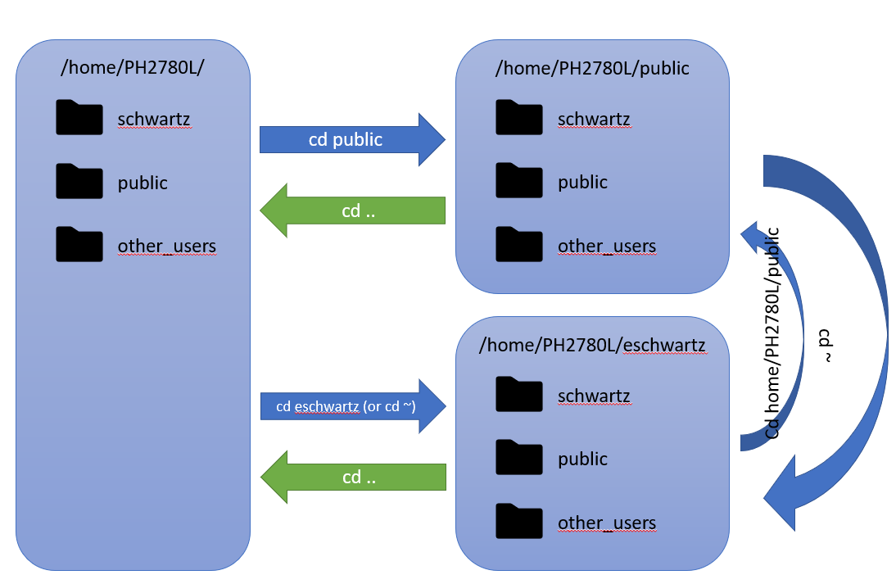
  - To create Lab1 in eschwartz:
    - cd home/PH2780L/eschwartz
    - mkdir Lab1
  - To copy pheno.txt and geno.txt from home/PH2780L/
    - cp home/PH2780L/public/Lab1/pheno.txt home/PH2780L/eschwartz/Lab1/pheno.txt
    - cp home/PH2780L/public/Lab1/geno.txt home/PH2780L/eschwartz/Lab1/geno.txt

- How do you move files from the server to your local computer and vice versa?
  - Using scp
    - scp <source location> <target location>
    - From server to local: scp ~/myFile.txt C:/PH2870L/Lab1/myfile.txt
    - From local to server: scp C:/PH2870L/Lab1/myfile.txt ~/myFile.txt
  - Using MobaXterm
    - Use Upload / Download icons:
      - Upload to the current folder:
      - Download selected files:

Managing Datasets: R 101

- What R function do you use to set an R working directory?
  - setwd(“path/to/mydir”)

- How do you check the number of individuals and variables in an R data frame?
  - To find the number of individuals, use nrow(df), where df is the data frame in question.
  - To find the number of variables, use ncol(df).

- What is the mean age in the merged dataset? What is the proportion of smokers in the merged dataset?
  - The mean age is 41.38.
  - The proportion of smokers (current or previous) is 0.314. Assumed that entries with no indication (“ “) are neither, or that data is missing.

- How do you export an R dataset?
  - With R-Studio: Click the icon in the Environment tab.

Hardy-Weinberg Equilibrium

Test HWE manually
1) What are the allele frequencies for SNP1? Use the following table to evaluate whether SNP1 is in HWE. Use the R function pchisq to calculate the p-value.

Genotype | Observed | Expected | Chi-square
AA | 280 | 278.81 | 0.016
AG | 694 | 696.37 | 0.016
GG | 436 | 434.81 | 0.016

Since χ² is 0.016 (p-value = 0.898), the null cannot be rejected. There is sufficient evidence to suggest that SNP1 is in HWE.

2) Evaluate the R code for testing HWE manually. What lines of code calculate the allele frequencies? What lines of code calculate the expected numbers of each genotype (AA, AG, and GG)? What lines of code calculate the chi-square statistic? What lines of code would you have to change, if any, to test another SNP?
- What lines of code calculate the allele frequencies?
  - table(pheno.geno$SNP1), to tabulate the genotypes
  - obs.aa <- 280, to manually assign the number of observations for AA (based on the table)
  - obs.ag <- 694, to manually assign the number of observations for AG (based on the table)
  - obs.gg <- 436, to manually assign the number of observations for GG (based on the table)
- What lines of code calculate the expected numbers of each genotype (AA, AG, and GG)?
  - N <- obs.aa+obs.ag+obs.gg, to determine the total of non-null observations
  - frq.a <- (obs.aa*2+obs.ag)/(N*2), to determine the frequency of the A allele
  - frq.g <- (obs.gg*2+obs.ag)/(N*2), to determine the frequency of the G allele
  - exp.aa <- frq.a^2*N, to determine the expected number of AA
  - exp.gg <- frq.g^2*N, to determine the expected number of GG
  - exp.ag <- 2*frq.a*frq.g*N, to determine the expected number of AG
- What lines of code calculate the chi-square statistic?
  - snp.chisq <- (obs.aa-exp.aa)^2/exp.aa +(obs.ag-exp.ag)^2/exp.ag +(obs.gg-exp.gg)^2/exp.gg, to calculate the χ² statistic based on the formula
- What lines of code would you have to change, if any, to test another SNP?
  - table(pheno.geno$SNP1), change the referenced variable $<SNP_number>

Test HWE using HardyWeinberg R package
3) Use the HWChisq function from the “HardyWeinberg” R package to test HWE for SNP1 and compare with your results from Q1. Are they consistent? Is this marker in HWE?
- Code output: Chi-square test with continuity correction for Hardy-Weinberg equilibrium (autosomal) Chi2 = 0.007785675 DF = 1 p-value = 0.9296887 D = -1.185106 f = 0.003403668
- This result is consistent with the manual calculation, with a slightly higher p-value due to continuity correction. The null cannot be rejected. Again, there is sufficient evidence to suggest that this marker is in HWE.

4) Select a subset of unrelated individuals and use the HWChisq function to test HWE for SNP1. Is this marker in HWE? How do your results in the unrelated subset compare to the results you observed including all generations?

SNP1 Table:
 |  | CHILD | GGP | GP | PARENT
 | 156 | 96 | 1 | 88 | 70
AA | 0 | 97 | 0 | 86 | 97
AG | 0 | 274 | 0 | 218 | 202
GG | 0 | 156 | 0 | 139 | 141

Code output:
Chi-square test with continuity correction for Hardy-Weinberg equilibrium (autosomal) Chi2 = 0.002251527 DF = 1 p-value = 0.9621544 D = -0.1647856 f = 0.001509512.

Based on the table data and R output, this marker is still found to be in HWE, which echoes the results from the previous two examples.

Test HWE using PEDSTATS
5) Prepare .ped and .dat input files, verify that PEDSTATS is interpreting the input files correctly. What are the number of pedigrees, number of individuals (how many founders and nonfounders?), average family size, average number of generations? Are there any Mendelian errors? What can you do to fix them in your analysis? (Note: use only trait6 and SNP1 in the pedigree file.)
- What are the number of pedigrees? There are 255 pedigrees, or families.
- Number of individuals (how many founders and nonfounders?)
  - 1821 individuals
  - 864 founders
  - 957 non-founders
- Average family size
  - 7.14 people
- Average number of generations
  - 2.83 generations
- Are there any Mendelian errors? What can you do to fix them in your analysis?
  - Yes. The ignoreMendelianErrors modifier was used to analyze the file.

6) After fixing any Mendelian errors, test Hardy-Weinberg equilibrium for SNP1 in only the founders. What is your conclusion?

The HWE check among founders is consistent with the rest of the findings. The null cannot be rejected. There is sufficient evidence to suggest that SNP1 among founders is in HWE.

